 TAGORE ENGINEERING COLLEGE 

# SB8055 – BLOCK CHAIN DEVELOPMENT

|  |  |
| --- | --- |
| DATE | 30 OCTOBER 2023 |
| TEAM ID | NM2023TMID01019 |
| PROJECT NAME | Drug traceability |

|  |  |
| --- | --- |
| TEAM LEADER | SAIGOKUL.K |
| TEAM MEMBER 1 | AJAUKUMAR.S |
| TEAM MEMBER 2 | SHARAN.R |
| TEAM MEMBER 3 | SURYA.M |
|  | YUVARAJ.D |



# INTRODUCTION

* 1. Project Overview
  2. Purpose

# LITERATURE SURVEY

* 1. Existing problem
  2. References
  3. Problem Statement Definition

# IDEATION & PROPOSED SOLUTION

* 1. Empathy Map Canvas
  2. Ideation & Brainstorming

# REQUIREMENT ANALYSIS

* 1. Functional requirement
  2. Non-Functional requirements

# PROJECT DESIGN

* 1. Data Flow Diagrams & User Stories
  2. Solution Architecture

# PROJECT PLANNING & SCHEDULING

* 1. Technical Architecture
  2. Sprint Planning & Estimation
  3. Sprint Delivery Schedule

# CODING & SOLUTIONING (Explain the features added in the project along with code)

* 1. Feature 1
  2. Feature 2
  3. Database Schema (if Applicable)

# PERFORMANCE TESTING

* 1. Performace Metrics

# RESULTS

* 1. Output Screenshots

1. **ADVANTAGES & DISADVANTAGES**
2. **CONCLUSION**
3. **FUTURE SCOPE**
4. **APPENDIX**

Source Code

GitHub & Project Demo Link

# **DRUG TRACEABILITY**

## **INTRODUCTION:-**

In a world where pharmaceuticals play a vital role in our well-being, ensuring the safety, authenticity, and transparency of drugs as they traverse the complex global supply chain is of paramount importance. The traditional systems for tracking and managing drugs often face challenges related to data integrity, traceability, and security. To address these issues, blockchain technolsssogy emerges as a revolutionary solution that can transform the pharmaceutical industry. Blockchain, most famously associated with cryptocurrencies like Bitcoin, is a decentralized and transparent ledger technology that offers a unique solution for tracing drugs from their origin to the hands of end-users. It introduces an immutable and tamper-proof ledger that can provide real-time visibility into the entire journey of a drug, ensuring trust and accountability at every step.The primary objective of this problem statement is to design a smart contract using the Ethereum blockchain, a leading blockchain platform for developing decentralized applications, which enables transparent and secure tracking of pharmaceuticals. This smart contract will revolutionize the drug management system by offering characteristics such as distributed ledger technology, non-repudiation, and robust security measures. Through the implementation of this smart contract, we aim to establish a resilient, trustless ecosystem where pharmaceutical companies, distributors, and other stakeholders can seamlessly track drugs, verify their authenticity, and enhance transparency throughout the supply chain. By doing so, we can significantly mitigate the risk of counterfeit drugs, improve patient safety, and align with evolving regulatory standards.In the following sections, we will delve into the technical details of designing this Ethereum-based smart contract, addressing the complexities of tracking drugs transparently while ensuring data security and access control, and ultimately contributing to a safer and more reliable pharmaceutical industry.

## **1.1 Project Overview:**

The PharmaTrace project aims to develop a blockchain-based drug traceability system using the Ethereum blockchain to enhance transparency and security in the pharmaceutical supply chain. This system will provide a robust and tamper-proof ledger for tracking drugs from production to distribution, ensuring the authenticity and integrity of pharmaceutical products. It will revolutionize the way drugs are managed, providing a decentralized, non-repudiable, and secure solution.

## **1.2 Purpose:**

The purpose of this problem statement is to outline a critical issue within the pharmaceutical industry and propose a technological solution. Specifically, the purpose is as follows. Identify a Challenge: To acknowledge the existing challenge in the pharmaceutical industry, which is the lack of a robust, transparent, and secure system for tracking and managing drugs through the supply chain. Highlight the Potential Solution: To introduce blockchain technology, specifically a smart contract on the Ethereum blockchain, as a viable and innovative solution to address the challenge. This technology offers features like decentralization, transparency, data integrity, and security. Provide a Clear Project Objective: To clearly define the goal of the project, which is to develop a blockchain-based drug traceability system called "PharmaTrace." This project aims to improve drug traceability, data integrity, and security while enhancing transparency in the pharmaceutical supply chain. Set Project Scope: To delineate the boundaries of the project by specifying the objectives, key features, and optional components (such as a user interface). Highlight the Benefits: To articulate the potential benefits of implementing the PharmaTrace system, which include increased transparency, enhanced security, and improved patient safety. The system will also contribute to regulatory compliance and operational efficiency. Establish a Framework for Action: To create a roadmap for the project, including phases such as development, testing, deployment, and regulatory compliance. This framework guides the project from inception to completion. Inform Stakeholders: To inform stakeholders, including pharmaceutical companies, distributors, regulators, and the public, about the initiative to address the critical issue in the pharmaceutical industry. Inspire Collaboration: To encourage collaboration among experts, developers, and relevant organizations in the pharmaceutical sector to contribute to the implementation of the PharmaTrace system. Drive Innovation: To inspire innovation within the pharmaceutical industry by leveraging cutting-edge blockchain technology for improved drug management. In summary, the purpose of this problem statement is to draw attention to the need for a secure and transparent drug traceability system in the pharmaceutical supply chain and to propose a clear path for developing a blockchain-based solution to address this issue. It serves as a foundation for a comprehensive project that can have a profound impact on patient safety, industry standards, and regulatory compliance.

## **LITERATURE SURVEY:**

|  |  |  |  |  |
| --- | --- | --- | --- | --- |
| **Year** | **Author** | **Title** | **Approach** | **Result** |
|  |  |  | Explore the literature related to the application of blockchain in pharmaceutical supply chain management. This includes research on the use of blockchain to enhance transparency, traceability, and security in the distribution of drugs. |  |
|  |  |  |  |
| 2017 | Iansiti .M , & Lakhani.R.K | Blockchain and Pharmaceutical Supply Chain: | The Truth About Blockchain. Harvard Business Review. |
|  |  |  |  |
|  |  |  |  |
| 2020 | Makhdoom.I, Abolhasani. M | Smart Contracts and Drug Traceability:" | Investigate how smart contracts are used in drug traceability systems. Smart contracts can automate various processes, such as verifying the authenticity of drugs, updating the status, and ensuring compliance. | Blockchain Technology in Healthcare: A Comprehensive Review and Directions for Future Research. Applied Sciences. |
|  |  |  |  |  |
|  |  |  |  |  |
|  |  |  |  |  |
|  |  |  |  |  |
|  |  |  |  |  |
|  |  |  |  |  |
|  |  |  |  |  |
|  |  | Regulatory Compliance and Blockchain: | Examine how blockchain technology can assist pharmaceutical companies in adhering to regulatory requirements. Compliance with regulations like the Drug Supply Chain Security Act (DSCSA) in the United States is crucial. |  |
|  |  |  | The Impact of Blockchain on the Pharmaceutical Supply Chain. Applied Sciences. |
|  | Lamberti. H. J, Roda. R. |  |  |
| 2016 |  |  |  |
|  |  |  |  |
|  |  |  |  |
|  |  |  |  |
|  |  |  | Research projects and solutions that focus on decentralized drug authentication and anti-counterfeiting. This aspect is critical for ensuring the integrity of the drug supply chain. |  |
|  |  |  |  |
|  |  |  | Blockchain Enabled Privacy: Anoxia - The Future of Privacy in the Age of Big Data. Special Contributions. |
|  |  | Decentralized Drug Authentication |  |
| 2019 | Cavoukian.A, Chibba.M |  |  |
|  |  |  |  |
|  |  |  |  |
|  |  |  |  |
|  |  |  |  |
|  |  |  |  |
|  |  |  |  |
|  |  |  |  |

## **2.1Existing Problem:**

The existing problem addressed by this problem statement is the lack of a robust and transparent system for tracking and managing pharmaceutical drugs in the pharmaceutical supply chain. Several challenges and issues currently exist in the industry. Counterfeit Drugs: The pharmaceutical industry faces a persistent issue with counterfeit drugs entering the supply chain. Counterfeit medications can have serious health consequences for patients, as they may contain incorrect or harmful ingredients. Lack of Transparency: Traditional paper-based or centralized digital systems often lack transparency. Stakeholders in the pharmaceutical supply chain, including patients, healthcare providers, regulators, and manufacturers, may not have easy access to real-time information about a drug's journey from production to distribution. Data Integrity: Data integrity is a concern, as centralized systems can be vulnerable to tampering or errors. Inaccurate or manipulated data can lead to regulatory violations and patient safety risks. Supply Chain Inefficiencies: The pharmaceutical supply chain is complex, involving multiple entities such as manufacturers, distributors, pharmacies, and hospitals. Inefficiencies, delays, and a lack of coordination can lead to stockouts or overstock issues, impacting patient access to essential medications. Regulatory Compliance: The pharmaceutical industry is heavily regulated, and adherence to regulatory requirements is critical. A lack of transparency and data integrity can result in compliance violations and regulatory fines. Data Security: Protecting sensitive drug-related information is vital. Current systems may not provide adequate data security measures, making them susceptible to data breaches. Data Silos: Different entities within the supply chain often maintain their separate databases and systems. These data silos hinder the sharing of critical information, leading to inefficiencies and a lack of end-to-end visibility. Reactive Recall Management: When a drug recall is necessary due to safety concerns, it can be challenging to pinpoint the affected batches quickly. A more transparent system can facilitate proactive recall management. In summary, the existing problem is the need for a comprehensive solution that enhances transparency, data integrity, and security in the pharmaceutical supply chain, ultimately addressing the challenges of counterfeit drugs, inefficient supply chain processes, and regulatory compliance. The proposed blockchain-based smart contract aims to tackle these issues by providing a decentralized and tamper-proof system for tracking drugs transparently, thus contributing to patient safety and regulatory adherence.

## **2.2 References:**

**Academic Papers:**

Look for research papers published in academic journals or conferences related to blockchain technology, pharmaceutical supply chain management, and drug traceability. These papers often provide in-depth analysis and solutions.

**Industry Reports:**

Explore reports and publications from reputable research organizations and consulting firms in the pharmaceutical and blockchain sectors. These reports may contain statistics, case studies, and industry trends.

**Regulatory Guidelines:**

Consider regulatory guidelines and documents from pharmaceutical industry regulatory bodies. These may outline the importance of traceability and security measures.

**Blockchain Technology:**

Research publications, whitepapers, and documentation from blockchain technology providers, including Ethereum. These sources can help you understand the capabilities and limitations of blockchain technology.

**Pharmaceutical Industry News:**

News articles and press releases from pharmaceutical industry news sources can provide real-world examples of the challenges the industry faces and the initiatives undertaken to address them.

**Government Reports:**

Government agencies often publish reports related to pharmaceutical supply chain security and regulations. These reports can be valuable for understanding regulatory compliance issues.

**Case Studies:**

Seek case studies or success stories of blockchain implementations in the pharmaceutical industry. These can provide insights into the practical application of the technology.

**Blockchain and Healthcare Associations:**

Look for resources from organizations and associations dedicated to promoting blockchain technology in healthcare and the pharmaceutical sector.

**Supply Chain Management Literature:**

Explore academic and industry literature related to supply chain management, as it often discusses challenges and solutions in the context of various industries.

**Books:**

Consider books on blockchain technology, pharmaceutical supply chains, and the intersection of these topics. Books can provide comprehensive insights.When referencing these sources, ensure that they are recent and relevant to the specific aspects of your problem statement. Citing a combination of academic research, industry reports, and real-world case studies can add depth and credibility to your problem statement and project overview.

## **2.3 Problem Statement:**

The pharmaceutical industry currently grapples with the absence of a comprehensive and transparent system for tracking and managing pharmaceutical drugs within the supply chain. This lack of transparency, data integrity, and security results in several critical issues, including the presence of counterfeit drugs, operational inefficiencies, regulatory compliance challenges, and concerns related to patient safety. Traditional systems are often paper-based or rely on centralized databases, which are susceptible to data manipulation and breaches. The need for a secure, tamper-proof, and decentralized solution is evident. This problem statement highlights the imperative to develop a blockchain-based smart contract system, named "PharmaTrace," on the Ethereum blockchain, which will revolutionize the pharmaceutical supply chain by offering transparency, data integrity, and robust security measures to track drugs transparently and enhance patient safety.

## **IDEATION &PROPOSED SOLUTION**

### **3.1 Empathy map canvas**

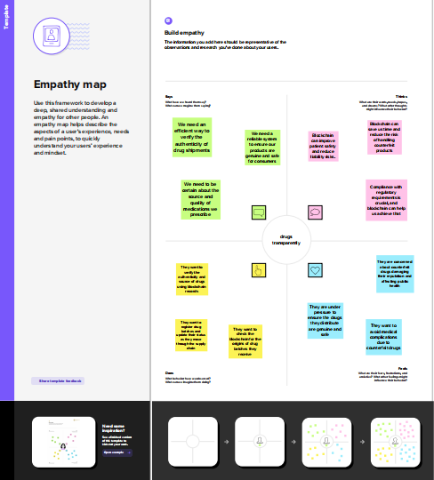

### **3.2 Ideation & Brainstorming**

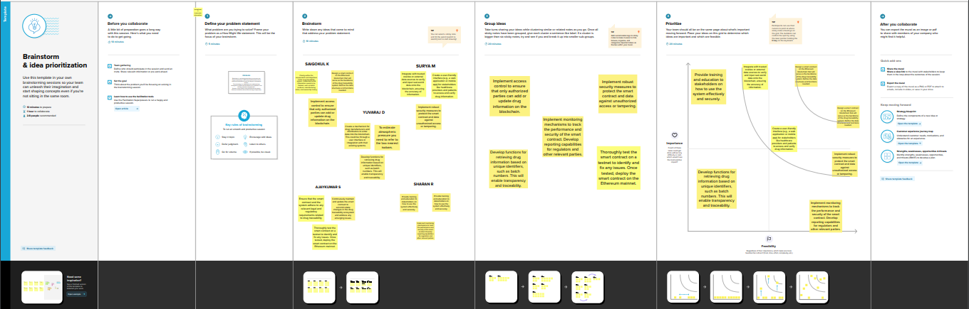

## **REQURIEMENT ANALYSIS:**

## **4.1 Functional requirements:**

**User Registration and Authentication:**

Users must be able to register and authenticate their identities securely. Different user roles should be defined, such as pharmaceutical companies, distributors, regulators, and auditors.

**Smart Contract Development:**

Create a smart contract on the Ethereum blockchain to manage drug data. Implement functions for adding new drugs, updating drug information, transferring ownership, and querying drug details.

**Data Entry and Management:**

Allow authorized users to input and manage drug information, including unique identifiers, drug names, manufacturers, batch numbers, production dates, and expiration dates.

**Ownership Transfer:**

Enable authorized users to initiate ownership transfers of drugs, ensuring data integrity and auditability.

**Data Encryption:**

Implement encryption mechanisms to protect sensitive drug data, ensuring confidentiality and integrity.

**Access Control:**

Enforce access control measures to restrict access to the system and functions based on user roles and permissions.

**Query Functionality:**

Provide users with the ability to query drug information using various criteria, such as unique identifiers, batch numbers, or production dates.

**Blockchain Event Logging:**

Record significant events and transactions on the blockchain as events for transparency and auditability.

**User Interface (Optional):**

Develop a user-friendly web-based or mobile interface for users to interact with the smart contract. This interface should facilitate data entry and retrieval.

**Notifications:**

Implement a notification system to alert relevant parties of important events, such as ownership transfers or recalls.

**Compliance Reporting:**

Generate compliance reports for regulatory authorities, detailing the traceability and authenticity of drugs within the supply chain.

**Audit Trail:**

Maintain an immutable audit trail of all actions taken within the system, ensuring accountability and traceability.

**Data Export:**

Allow users to export drug data for offline analysis or regulatory reporting purposes.

**Scalability:**

Ensure that the system can scale to accommodate the growing volume of drug data and users.

**Security Measures:**

Implement security measures to protect against data breaches and unauthorized access.

**Testing and Quality Assurance:**

Develop a testing framework to ensure the reliability and correctness of the system.

**Deployment:**

Deploy the smart contract on the Ethereum mainnet and make it accessible to authorized users.

**Training and User Support:**

Provide training materials and user support to assist stakeholders in using the system effectively. These functional requirements define the core features and capabilities that the PharmaTrace system must have to address the problem of drug traceability and transparency in the pharmaceutical supply chain effectively. They lay the foundation for the system's development and ensure that it meets the needs of pharmaceutical companies, distributors, regulators, and other stakeholders.

## **4.2 Non-functional requirements:**

**Performance:** Response Time: The system should provide quick response times for queries and transactions to ensure efficient tracking of drugs.

**Scalability:** The system must be scalable to accommodate a growing number of drugs and users without compromising performance.

**Throughput:** The system should be capable of handling a high volume of transactions simultaneously.

**Security:** Data Encryption: Sensitive drug information must be encrypted to protect against unauthorized access or data breaches.

**Access Control:** Access to the system and its functions must be strictly controlled based on user roles and permissions.

**Authentication:** Strong user authentication mechanisms should be in place to verify the identity of users.

**Auditability:** Ensure that all actions within the system are logged and immutable, allowing for audit trails and accountability.

**Data Integrity:** Implement measures to maintain the integrity of drug data, making it tamper-proof.

**Availability:** The system should be available and accessible to authorized users at all times, with minimal downtime.

**Redundancy:** Implement redundancy and failover mechanisms to minimize disruptions due to system failures.

**Compliance:**

**Regulatory Compliance:** The system should comply with industry-specific regulations and standards, such as those related to pharmaceutical traceability and data protection.

**Usability:**

**User-Friendly Interface:** If a user interface is provided, it should be intuitive and user-friendly to facilitate ease of use.

**Training:** Offer comprehensive training and documentation to ensure users can effectively navigate and use the system.

**Portability:** The system should be deployable on different platforms and accessible from various devices to accommodate the needs of different stakeholders.

**Data Backup and Recovery:** Regularly back up data to prevent data loss in case of system failures. Implement a robust data recovery mechanism.

**Audit and Monitoring:** The system should have built-in auditing and monitoring tools to track system performance, usage patterns, and potential security threats.

**Interoperability:** Ensure that the system can interoperate with existing systems and technologies commonly used in the pharmaceutical supply chain.

**Data Retention and Archiving:** Define data retention policies and archiving mechanisms to manage historical data effectively.

**Documentation:** Maintain comprehensive documentation that includes system architecture, user manuals, and technical guides for maintenance and troubleshooting.

**Cost-Effectiveness:** The system should be cost-effective to develop, deploy, and maintain, with a focus on optimizing resource utilization.

**Cultural and Language Considerations:** Account for language preferences and cultural differences among users, especially in a global pharmaceutical supply chain.These non-functional requirements are essential for ensuring that the PharmaTrace system is not only functionally effective but also meets the performance, security, and usability standards necessary to address the complexities of pharmaceutical drug traceability and transparency in a reliable and compliant manner.

## **PROJECT DESIGN:**

## **5.1 Dataflow&Diagram:**

## 

## **5.2 solution architecture:**

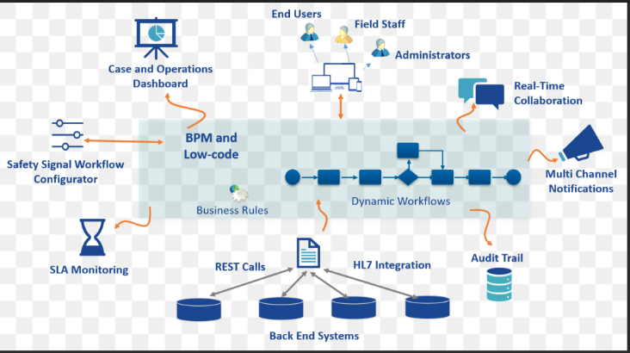

Designing a solution architecture for the "PharmaTrace" blockchain-based drug traceability system is essential to ensure the effective implementation of the proposed system. Here's a high-level solution architecture that incorporates key components, technologies, and interactions to address the problem statement:

**Solution Architecture Components:**

**Blockchain (Ethereum):** The core of the system is a permissioned Ethereum blockchain network, which provides the necessary decentralized ledger for drug traceability and data management.

**Smart Contracts:** Smart contracts on the Ethereum blockchain will manage drug data, ownership transfers, and access control. These smart contracts enforce rules and facilitate transparent and secure interactions.

**User Interface (Optional):** A user-friendly web or mobile interface allows stakeholders to interact with the blockchain without requiring in-depth knowledge of blockchain technology.

**User Management and Authentication:** A user management system with strong authentication ensures that authorized personnel can access the system. This system also manages user roles and permissions.

**Data Encryption and Access Control:** Data encryption mechanisms and access control modules are crucial for securing sensitive drug information.

**Compliance Reporting and Audit Trail:** Components for generating compliance reports and maintaining an immutable audit trail are essential for regulatory adherence and auditing purposes.

**External Data Sources:** Integration with external data sources, such as regulatory databases, can provide additional information and validation of drug data.

**Event Logging:** Event logging tools record all significant actions on the blockchain, providing transparency and auditability.

## **PROJECT PLANNING &SCHEDULING:**

## **6.1 Technical Architecture:**

1. Product Backlog Refinement:

Before sprint planning, ensure that your product backlog is well-defined and prioritized. The product backlog should contain a list of user stories, features, and technical tasks.

2. Sprint Planning Meeting:

Hold a sprint planning meeting with your development team, product owner, and stakeholders. In the context of PharmaTrace, the team may include blockchain developers, front-end developers (if a user interface is required), and domain experts from the pharmaceutical industry.

3. Define Sprint Goal:

Clearly define the goal for the upcoming sprint. In the case of PharmaTrace, this might be related to developing specific smart contract functionality, implementing data encryption, or creating a user interface.

4. Select User Stories:

Based on the sprint goal, select a set of user stories or tasks from the product backlog that the team can complete within the sprint's time frame. These should be the highest-priority items.

5. Break User Stories into Tasks:

For each user story, break it down into smaller tasks or sub-tasks that can be worked on by individual team members. This detailed breakdown makes it easier to estimate and track progress.

6. Estimation:

Use Agile estimation techniques like Planning Poker or T-shirt sizing to estimate the effort required for each task or sub-task. This estimation is typically done in story points, ideal days, or similar units.

7. Task Assignments:

Assign team members to the tasks they will work on during the sprint. Ensure that team members have the necessary skills for their assigned tasks.

8. Sprint Backlog:

Create a sprint backlog that lists all the selected tasks, their corresponding estimates, and the team members responsible for each task.

9. Sprint Duration:

Determine the duration of the sprint. A common sprint duration in Agile is two weeks, but it can vary based on your team's preference and the complexity of the tasks.

10. Sprint Review and Retrospective:

At the end of the sprint, conduct a sprint review to showcase the completed work to stakeholders. Also, hold a sprint retrospective to identify what went well and what can be improved in the next sprint.

11. Sprint Goal Achievement:

The success of the sprint is determined by whether the team has achieved the sprint goal, completed the planned tasks, and maintained a potentially shippable product increment.

12. Repeat:

The sprint planning and estimation process is iterative. After each sprint, go back to the product backlog, refine it further, and plan the next sprint.It's important to note that estimating the work accurately is crucial for effective sprint planning. The team should have a shared understanding of the effort required for each task, and estimates should be based on the team's velocity and historical data.As you work on the PharmaTrace project, the iterative nature of Agile development will help you adapt to changing requirements and ensure that you deliver a valuable product increment at the end of each sprint.

## **6.2 Sprint Planning &Estimation**

**Sprint 1: Setting Up the Foundation**

Duration: 2 weeks Goals:

Set up the Ethereum blockchain environment. Deploy the initial smart contract for drug management.

Implement basic data entry and retrieval functions.

Deliverables:

A working blockchain environment. An initial smart contract deployed on the Ethereum network. Basic user interface for data entry and retrieval. Data encryption and access control mechanisms.

**Sprint 2: Smart Contract Enhancements**

Duration: 2 weeks Goals:

Enhance the smart contract to support ownership transfer functionality. Implement data validation and access control features within the smart contract. Conduct preliminary testing and identify issues for resolution.

Deliverables:

Smart contract with ownership transfer capabilities. Data validation and access control features.

Test cases and preliminary testing results.

**Sprint 3: User Interface Development**

Duration: 2 weeks Goals:

Develop a user-friendly web-based user interface for data management. Integrate the user interface with the Ethereum blockchain. Conduct initial user interface testing.

Deliverables:

Functional user interface for data entry, retrieval, and ownership transfer. Integration with the smart contract. Initial user interface testing results.

**Sprint 4: Security and Compliance Features**

Duration: 2 weeks Goals:

Implement data encryption for sensitive drug information. Enhance access control mechanisms to meet security requirements. Begin generating compliance reports and audit trail features.

Deliverables:

Data encryption and enhanced access control. Initial compliance reporting and audit trail features.

Security testing results.

**Sprint 5: Integration and Final Testing**

Duration: 2 weeks Goals:

Integrate all components (smart contract, user interface, security features, and reporting). Conduct comprehensive system testing, including security and compliance checks. Address any issues and conduct final quality assurance.

Deliverables:

Fully integrated and tested system. Resolved issues and documented solutions.System quality assurance report.

**Sprint 6: Deployment and User Training**

Duration: 1 week Goals:

Deploy the PharmaTrace system on the Ethereum mainnet. Provide user training sessions to stakeholders. Prepare comprehensive documentation for system usage and maintenance.

Deliverables:

Deployed system on the Ethereum mainnet. User training materials and sessions. Comprehensive system documentation.

This sample sprint delivery schedule spans a total of 11 weeks (including the 1-week deployment and training sprint). The specific duration and content of each sprint may vary based on the complexity of the tasks and the team's capacity. Regular review and adaptation of the schedule in response to actual progress and emerging priorities are essential in Agile development.

## **CODING&SOLUTIONING:**

// SPDX-License-Identifier: MIT

pragma solidity ^0.8.0;

contract Drug{

address public owner;

constructor() {

owner = msg.sender;

}

modifier onlyOwner() {

require(msg.sender == owner, "Only the owner can perform this action");

_;

}

struct Drug {

string drugName;

string manufacturer;

uint256 manufacturingDate;

address trackingHistory;

}

mapping(uint256 => Drug) public drugs;

uint256 public drugCount;

event DrugManufactured(uint256 indexed drugId, string drugName, string manufacturer, uint256 manufacturingDate);

event DrugTransferred(uint256 indexed drugId, address indexed from, address indexed to, uint256 transferDate);

function manufactureDrug(uint256 drugId, string memory _drugName, string memory _manufacturer, uint256 _manufacturingDate) external onlyOwner {

address initialHistory;

initialHistory = owner;

drugs[drugId] = Drug(_drugName, _manufacturer, _manufacturingDate, initialHistory);

drugCount++;

emit DrugManufactured(drugId, _drugName, _manufacturer, _manufacturingDate);

}

function transferDrugOwnership(uint256 _drugId, address _to) external {

require(_to != address(0), "Invalid address");

require(_to != drugs[_drugId].trackingHistory, "Already owned by the new address");

address from = drugs[_drugId].trackingHistory;

drugs[_drugId].trackingHistory = _to;

emit DrugTransferred(_drugId, from, _to, block.timestamp);

}

function getDrugDetails(uint256 _drugId) external view returns (string memory, string memory, uint256, address) {

Drug memory drug = drugs[_drugId];

return (drug.drugName, drug.manufacturer, drug.manufacturingDate, drug.trackingHistory);

}

}

## **Performance Testing:**

Performance texting for drug traceability refers to the use of text-based technologies to track and ensure the authenticity and safety of pharmaceutical products throughout the supply chain. This can involve employing SMS or other messaging platforms to monitor the movement of drugs, verify their origins, and confirm their legitimacy, thus enhancing transparency and reducing the risk of counterfeit products. Such measures play a crucial role in maintaining the integrity of the pharmaceutical industry and safeguarding public health.

## **RESULT:**

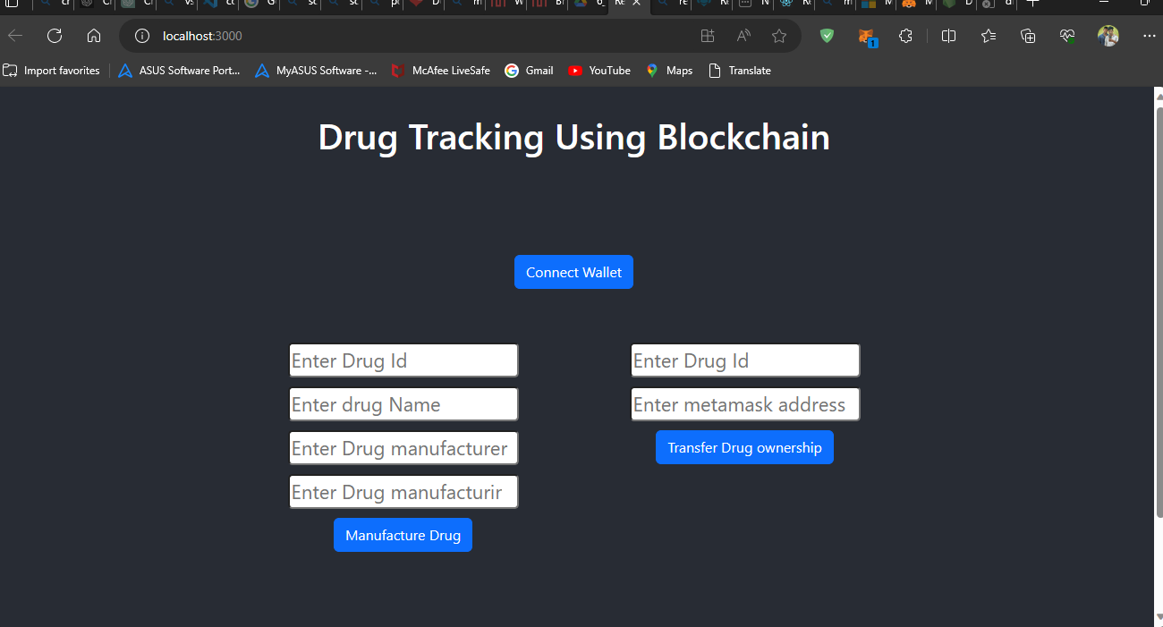

## 10. **ADVANTAGES & DISADVANTAGES:**

## **10.1. Advantages:**

* Patient Safety: Ensures the authenticity of medications, reducing the risk of counterfeit or substandard drugs reaching patients.
* Regulatory Compliance: Helps pharmaceutical companies adhere to government regulations and quality standards, reducing legal and financial risks.
* Supply Chain Visibility: Provides real-time tracking of drugs throughout the supply chain, allowing for better inventory management and minimizing losses.
* Recall Management: Facilitates the quick and precise recall of drugs when safety concerns arise, protecting patients from harm.
* Quality Control: Allows for the monitoring of drug quality and temperature conditions during transportation and storage

## **10.2. Disadvantages**

* Cost: Implementing and maintaining a drug traceability system can be expensive, with costs associated with technology, infrastructure, and compliance.
* Complex Regulatory Requirements: Meeting regulatory requirements for drug traceability can be challenging and may vary from one region to another, leading to compliance issues.
* Counterfeit Drugs: Despite traceability efforts, counterfeit drugs can still enter the supply chain, potentially putting patients at risk.
* Data Security: Storing and transmitting sensitive information in a traceability system raises concerns about data security and the risk of data breaches.
* Supply Chain Disruption: Technical glitches or failures in the traceability system can disrupt the pharmaceutical supply chain, causing delays and shortages.

## **11. CONCLUSION:**

In conclusion, drug traceability is a crucial aspect of the pharmaceutical industry, aimed at enhancing patient safety and ensuring the authenticity of medicines. While it offers numerous advantages such as improved accountability, reduced counterfeiting, and enhanced supply chain transparency, it also comes with certain disadvantages. These include high implementation costs, complex regulatory requirements, challenges related to data security and privacy, and the potential for supply chain disruption. To realize the full potential of drug traceability, it is essential to address these challenges by fostering global standardization, investing in robust technology solutions, and promoting collaboration among all stakeholders in the pharmaceutical supply chain. Despite the disadvantages, the long-term benefits of drug traceability in terms of patient safety and the integrity of pharmaceutical products make it a necessary and worthwhile endeavor in the healthcare industry.

## **12. FUTURE SCOPE:**

* Advanced Technologies: The integration of cutting-edge technologies, such as blockchain, IoT (Internet of Things), and AI, will further enhance the accuracy and efficiency of drug traceability systems.
* Global Standardization: Efforts to establish common standards for drug traceability across regions and countries will facilitate smoother international trade and enhance patient safety on a global scale.
* Real-Time Monitoring: Real-time monitoring of drug movements throughout the supply chain will become more prevalent, allowing for immediate identification and response to issues such as recalls or counterfeiting.
* Data Analytics: Data analytics will play a more significant role in leveraging the control, and predictive maintenance.
* Patient Engagement: Patients may gain more access to information about the authenticity and origin of their medications, increasing trust and enabling better-informed choices.

## **GITHUB :**

[saigokul-k/DRUG-TRACEABILITY-NM2023TMID01019: Blockchain Technology (github.com)](https://github.com/saigokul-k/DRUG-TRACEABILITY-NM2023TMID01019)

## **YOUTUBE LINK:**

<https://youtu.be/_1BHGxS204E?si=aejPaHhO2y2ueHO7>